Bubble Snake Maker
You Will Need:
One plastic bottle
One rubber band
One sock or washcloth

- Cut the bottom off of your plastic bottle. Put the bottom piece of the bottle in the recycling bin.

- Stretch the sock or washcloth over the larger opening in the bottle (where the bottom used to be). You may need to trim the cloth if you have a lot of extra fabric.

- Use the rubber band to secure the fabric in place.

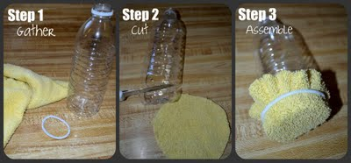

- Dip the fabric in the bubble solution.

- Blow into the mouthpiece of the bottle. A bubble snake will grow out of the fabric!
Bubble Snake Tips:
- Don’t breathe in while your mouth is over the bottle’s opening!
- Keep the lid to your bottle! It will help the bottle’s opening to stay clean between bubble blowing sessions.
Project idea and photos: http://www.cometogetherkids.com/2011/04/bubble-snake-maker.html

Gigantic Bubble Maker
You Will Need:
Four Straws
One piece of string

- Thread the string through two of the straws.
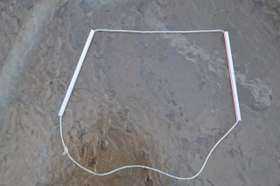
- Tie the two ends of the string together.

- Move the knot so that it is inside one of the straws.
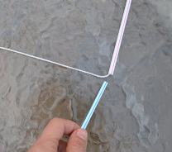
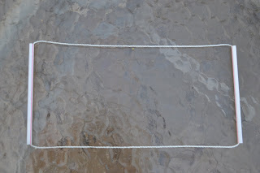
- Insert each of the two remaining straws into one of the straws on the string. You will need to pinch the ends a little bit to make them fit.

- Your finished product will look like this:
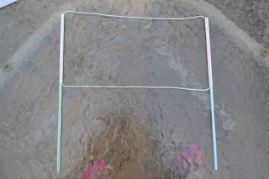
- Try out your new bubble maker!

Project idea and photos: http://www.cometogetherkids.com/2011/04/really-big-bubble-maker.html

