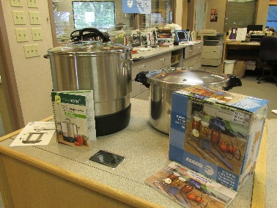

Inventory List for Canning Maker Box Kit (3 Boxes)
1 Ball Freshtech Electric Canning Water Bath in original box with cord, instruction manual and recipe booklet.
1 Bin with Pressure Cooker and 8 Piece home canning kit that includes:
- Canning Rack
- Jar Wrench
- Jar Lifter
- Wide Mouth Funnel
- Magnetic Lid Lifter
- Ladle
- Bubble Freer
- Cookbook

1 Bin with regular stove top water canning bath and 8 piece home canning kit same as above

