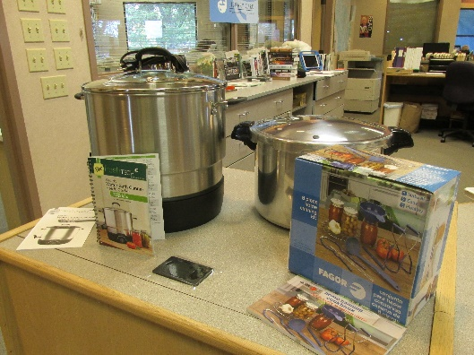

Programming Ideas for Canning Maker Box Kit
- Contact your local county UW-Extension office and see if the Family Living Resource agent is available to do a canning program. The Extension is usually looking for opportunities to get out in local communities to educate people about various things. The Waupaca County agent, Sandy Liang was very excited to do a program for us. This was free of charge. The Library paid for posters and flyers to publicize the program and for refreshments after the program and for staff time to plan and have the program. We opted to focus our program on canning meat and poultry because we had our program at the end of September. This was very well received. We had 40 people attend and probably had at least that tell us they would love to attend but had other commitments. For safety reasons and because the Library did not have a proper kitchen no actual canning was done.
- A program on canning fruits and vegetables would be popular as well but many people already do this – the meat and poultry focus really seemed to grab people’s interest.
- Consider making the kit available to community kitchens for a certain period of time – if you have a community kitchen in your area let them know the kits are available.
- Always check with your local fire department before doing any cooking programs in your library. It might not be legal to conduct such programs depending on what is being cooked and how your facility is set up.
- The materials are great to use in displays as they grab a lot of attention – it helps people become aware of resources/materials that are out there for them to purchase.

